**Instagram Photo Download APP from Command Line**

Steps:

1. pip install instaloader

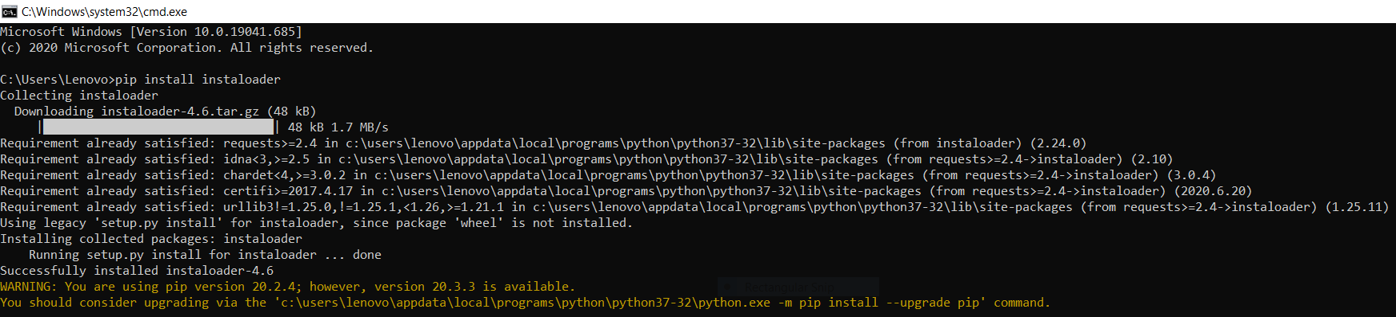

1. instaloader –help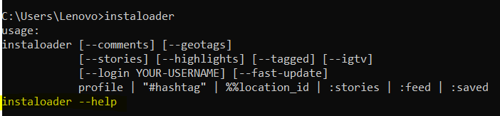

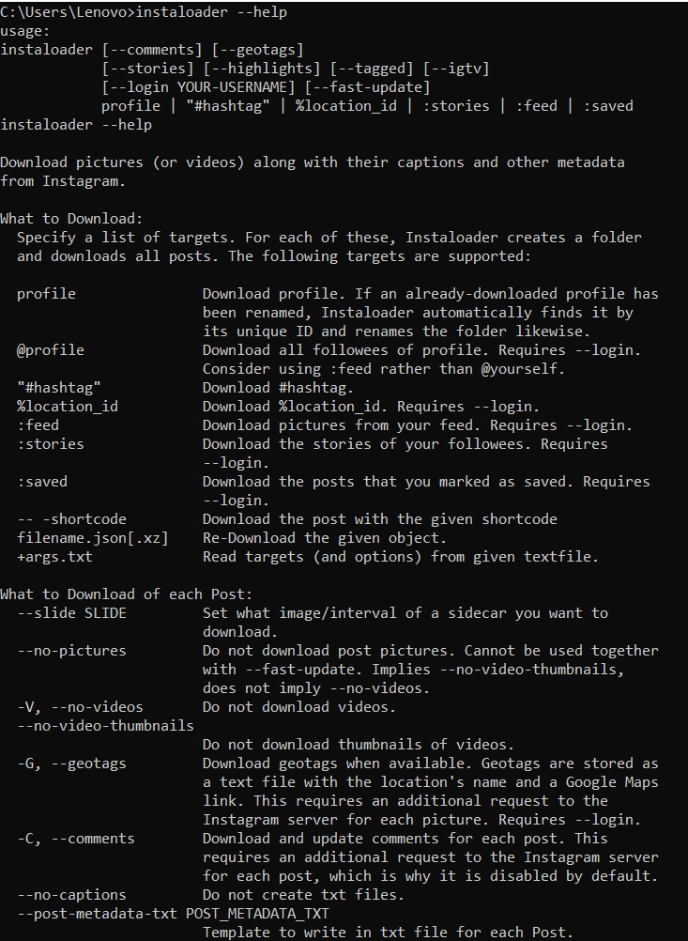

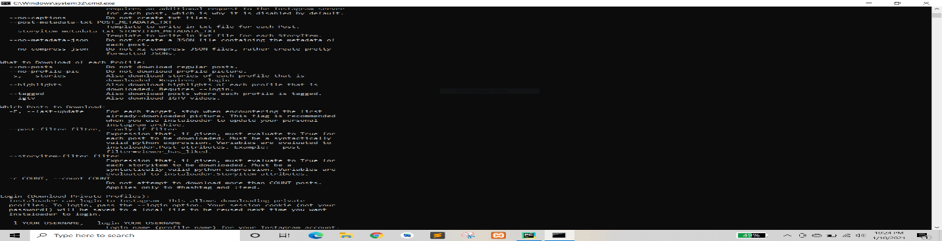

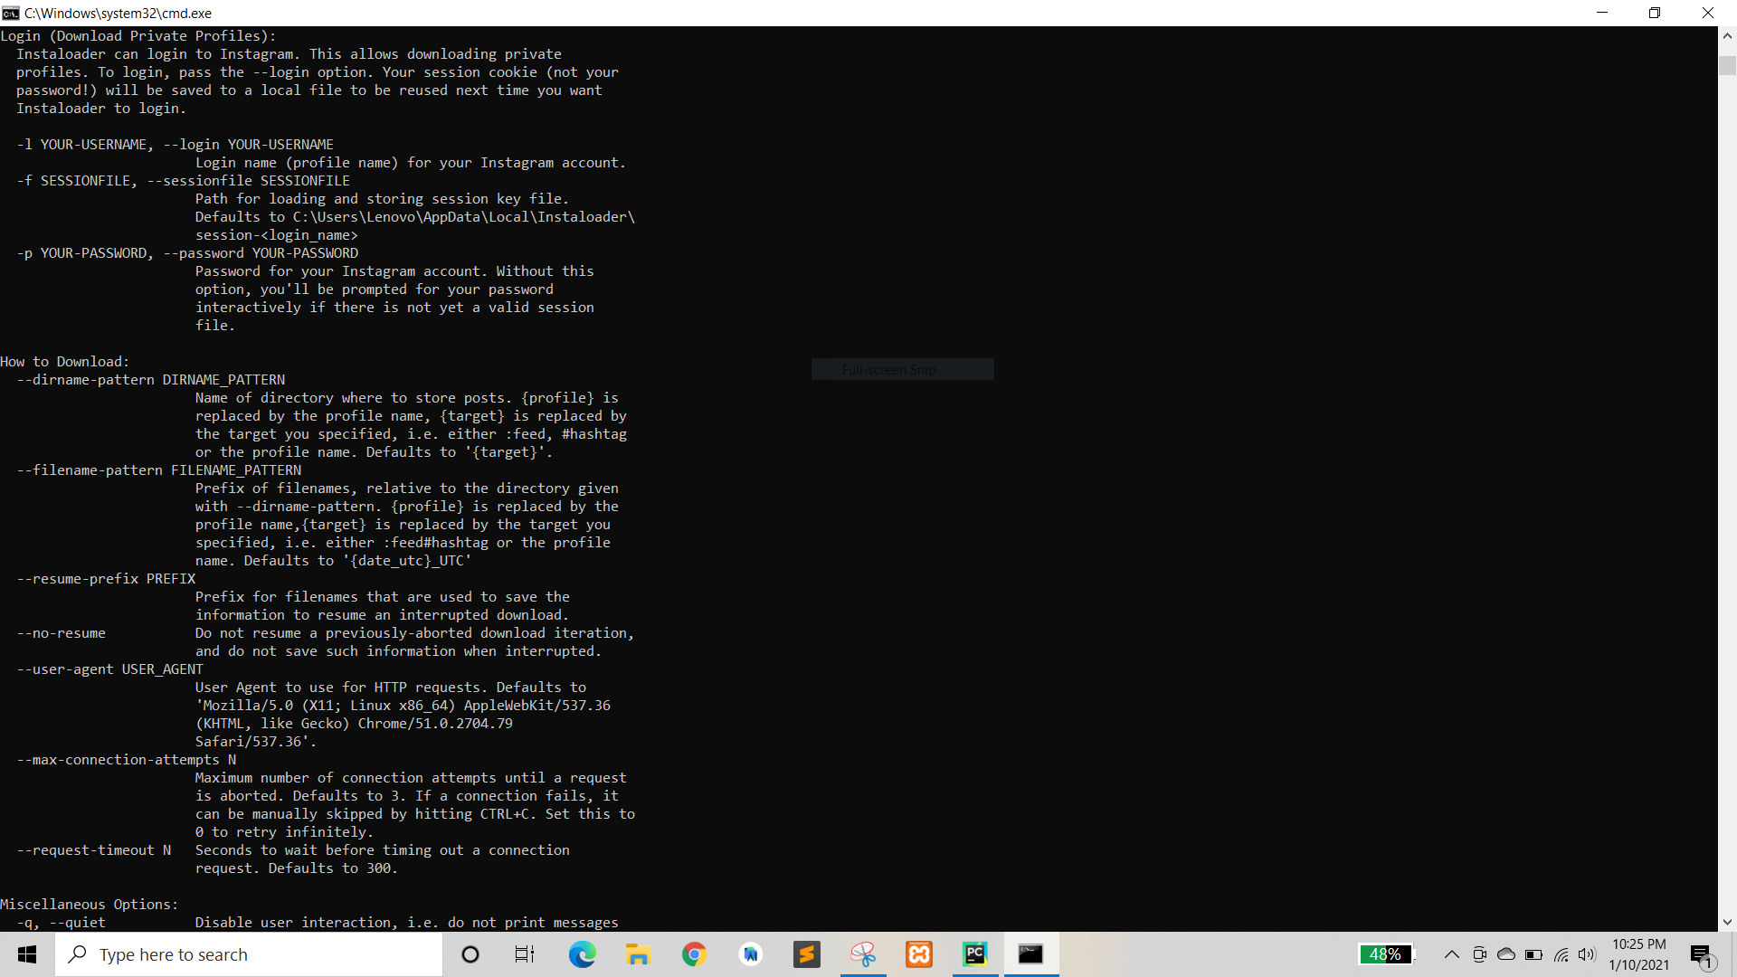

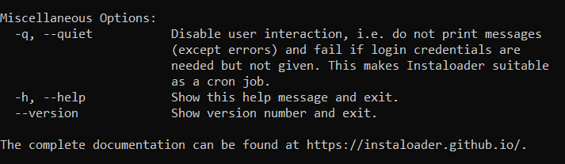

1. instaloader profile <profile_id>

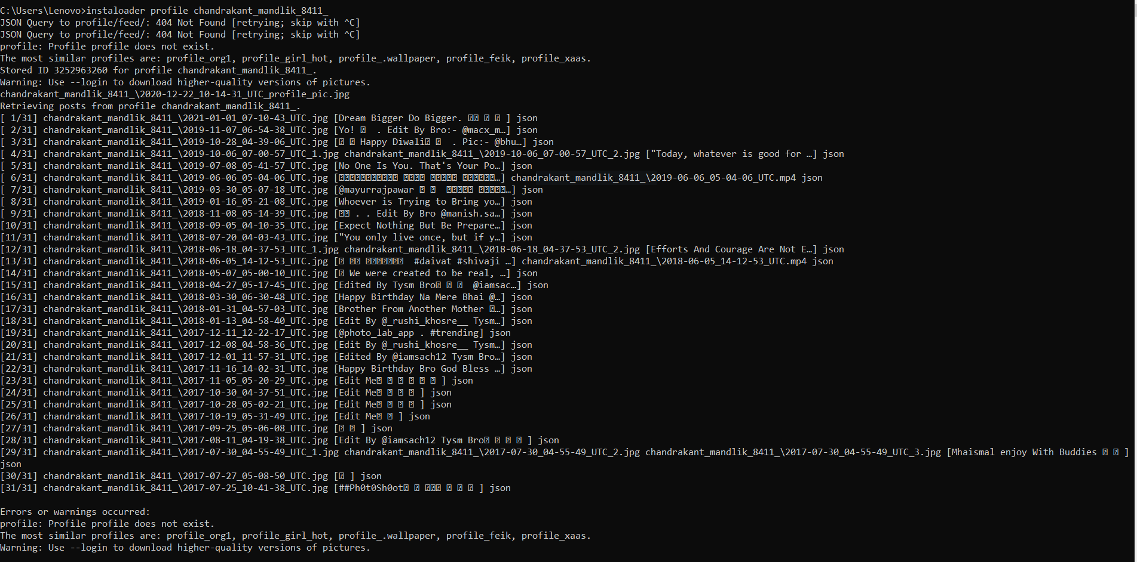

1. instaloader --no-captions --no-videos --no-compress-json --no-metadata-json profile <profile_id>

